**Introduction**

The bookstore is being maintained manually over the last 50 years as told by the booksellers. They maintained their records on a single diary and analyse their daily sales in the same diary. Whenever they have sold out their stock of any book they write an email to suppliers for the request of new books.

In an attempt to do automation we came up with an idea to make database of the cos bookstore. We requested shopkeeper to completely analyse how they maintain their stock of various books and stationery. He told us that he mainly keep different subjects books into different containers present in his shop. For stationery he has different sized boxes to store the items like rubber and sharpener.

Below we are going to show our ideas how we are going to manage this database. We have given a detailed description of each and every table which we are going to make all with constraint and data types. After completion of this project we will make front end for this database and would like to gift this GUI to the booksellers so that their work becomes easy to manage. We have also included bill generation system which will ensure tax transparency since the shopkeepers do not give any bill or invoice presently. This might be a contributor to black Money.

**Pictures of manual data handling**

Since 50 years all the transactions i.e. selling of a book , purchase of new book or stationary item are handled manually. In this project named The Cos Bookstore, we are going to automate all the manual databases kept by the shop keepers.

Below are some pictures of manual database captured from COS bookstore by our mobile phone c ar.

Daily dairy records of sale

­­­­­­**Questions asked to shopkeepers with their answers**

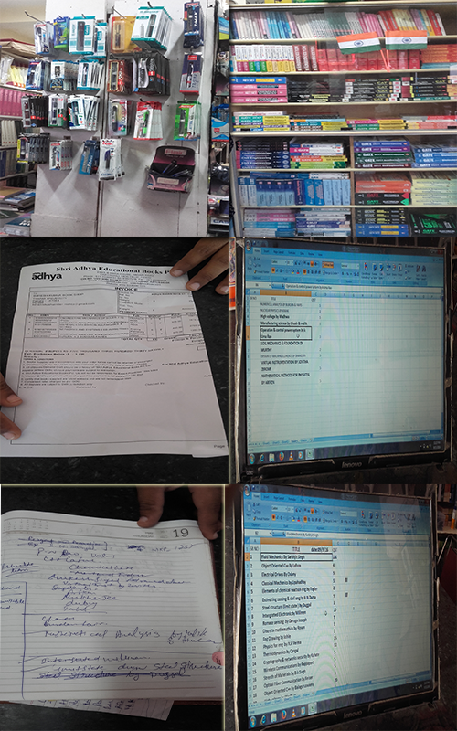

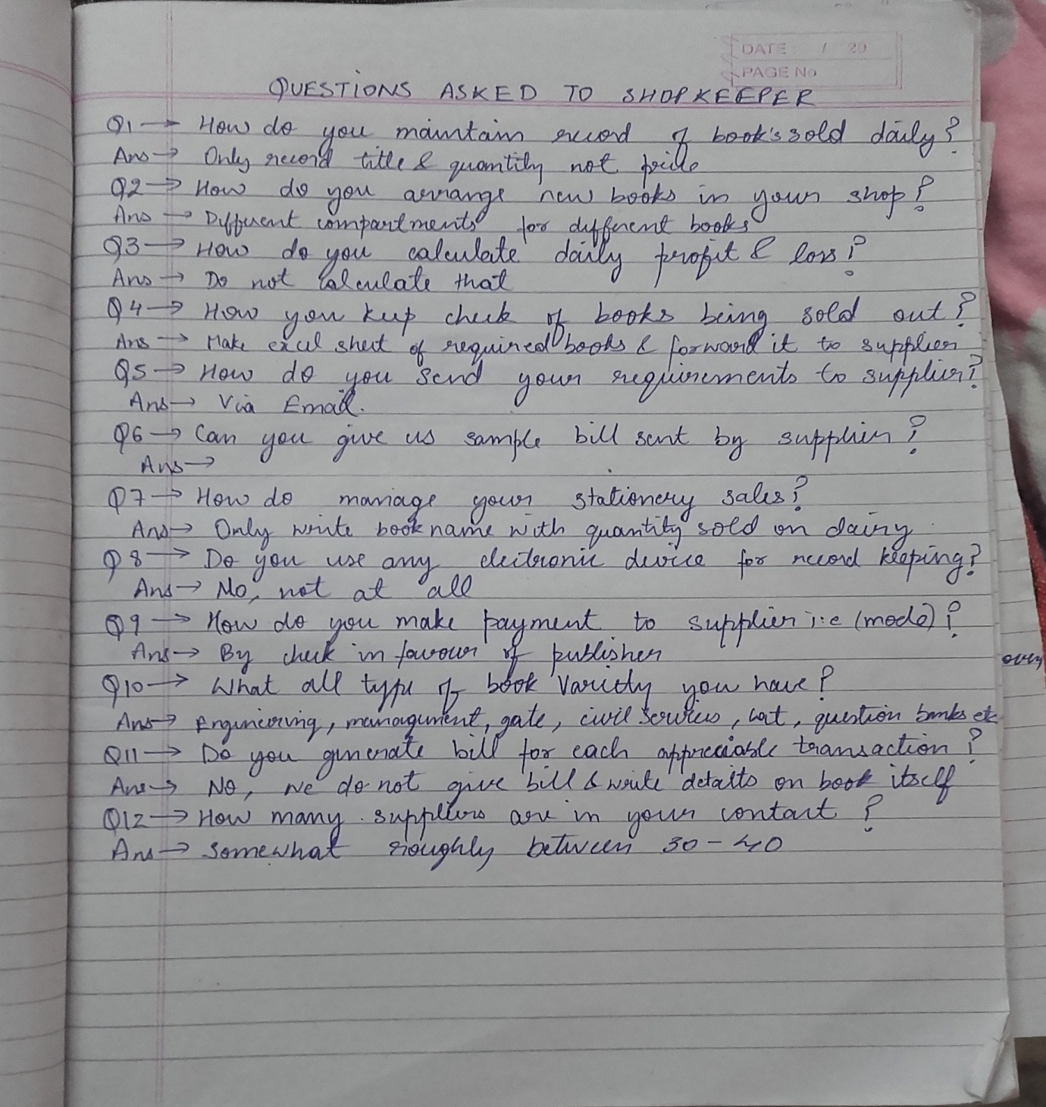

**Present Scenario**

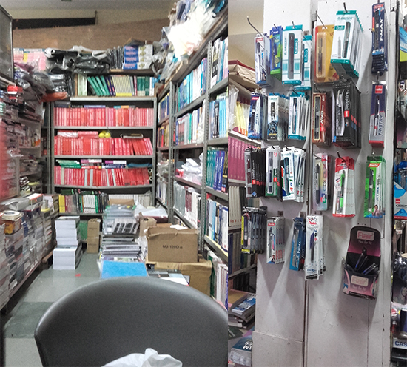

**Management of Books & Stationery**

From a long time, the shopkeepers are managing their shop in a similar manner. They have many slabs as there shop furniture cut into different compartments. For simplification of various transactions they arrange different subject books into different compartments for easy retrieval. For example consider three compartments named compartment A, compartment B and compartment C. He will always keep Java,The complete reference by Herbert Schield in compartment A,Korth DBMS in compartment B and Discreate Mathematics by Rosen in compartment C multiple copies in same compartment.

For stationery items he extracts all the units from a pack,and keeps it in different sized boxes for reference purpose example rubber,sharpner and pen in different compartments.

**Daily Record Insertion**

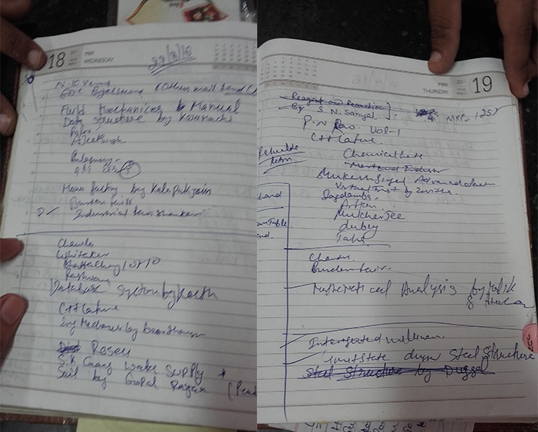

Shopkeeper has kept a dairy to insert all the entries of sale of books such as

The complete reference by Herbert Schield - 1 unit

Database Management System by Korth - 1 unit

Physics by N.K.Verma - 1 unit

They do not keep any record for each unit sold. They order stationary item when their considerable item sold out. They do not explicitly write the amount at which they sell the any item. They only check the cashbox at the end of the day.

For old books they do not keep any record of purchasing or selling.

They sell old book at __% of the original prize and purchase books at __% of the original prize.

They do not create any type of bill but and if anybody asks them for the bill write it on a simple , blank pad paper and write amount on it with their signature.

**Requirement Item Management**

At the end of the day they go through the all the record and make a excel sheet for it in which they write all the required item and their quantity.

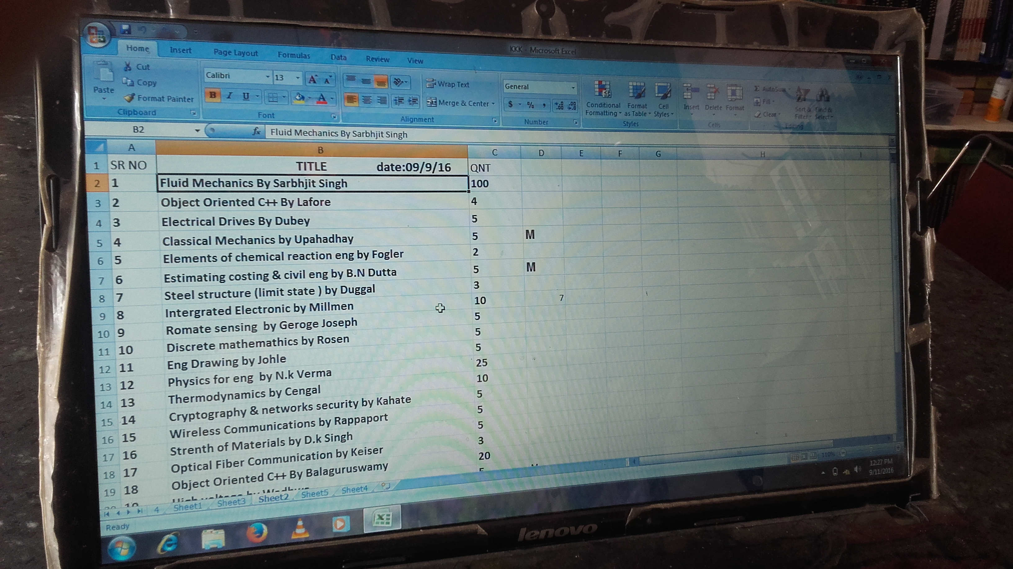

As the required items are going on increasing the added it inside excel sheet. After a specific time they have sufficient items then they send a email to the supplier.

**Supplier record with Bill**

After sending the requirement item mail to wholesale company. Company send the required item to bookstore with a bill.

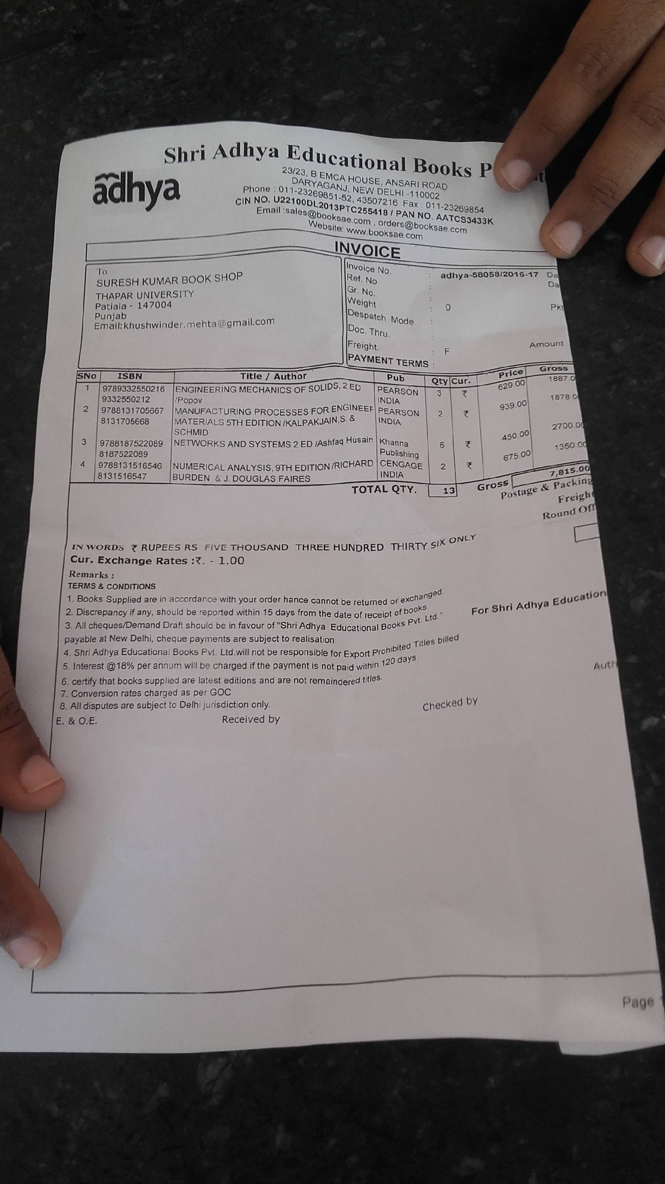

The bill contains all the detail about the sending item like quantity, prize, discount, total amount. They pay the bill through banking.

**Automation of Old System**

To create the database of the whole bookstore for easy calculation of all the records and managing all cash. Than we require some unique property of a book. Then we got ISBN (International Standard Series Book Number) which is unique for every book like

Java The complete reference - 978-93-3290-138-4

Discrete mathematics and application - 978-0-0-07-0681880

This ISBN number uniquely defines a book of particular subject. Now each compartment we have a unique ISBN number. We create the database of new books as in following table.

New_Book table

|  |  |  |  |  |  |  |  |
| --- | --- | --- | --- | --- | --- | --- | --- |
| **ISBN** | **TITLE** | **AUTHOR** | **SUPPLIER** | **EDITION** | **PRICE** | **DISCOUNT** | **QTUANTITY** |
| 978-0-0-07-0681880 | Discrete mathematics and application | Kenneth H Rosen | Shri Adhya  Educational  Books Pvt.  Ltd. | 7 | 550 | 10 | 10 |
| 978-93-3290-138-4 | Database System Concepts | Henry F. Korth ,  S.Sudarshan | Shri Adhya  Educational  Books Pvt.  Ltd. | 6 | 650 | 10 | 15 |
| 978-93-392-1209-4 | Java The complete  Reference | Herbert Schildt | Bala ji  Books store | 9 | 700 | 15 | 14 |
| 0-07-114717-9 | Principle of material science | William F.Smith | Bala ji  Books store | 3 | 650 | 10 | 10 |

|  |  |  |
| --- | --- | --- |
| **Column name** | **Datatype** | **constraints** |
| ISBN | Varchar2(20) | Primary Key |
| Title | Varchar2(60) | not null |
| Author | Varchar2(30) | not null |
| Supplier | Varchar(60) | not null |
| Price | Number(5,2) | not null,check(price>0) |
| Discount | Number(2) | not null,check(discount>0) |
| Quantity | Number(5) | not null,check(quantity>=0) |
| Edition | Number(2) | not null,check(edition>0) |

In this table we use ISBN number as primary to uniquely define every books. Now what is the benefit of doing this when they will sell they book they just write the ISBN number in the daily record table and it will update the New_Book table. It will reduce the quantity of book in the database of new books.

**Old Book’s table**

We do all the same procedure for new book. In this also we take ISBN as the primary key of the table.

**Old_books table**

|  |  |  |  |  |  |
| --- | --- | --- | --- | --- | --- |
| **ISBN** | **TITLE** | **AUTHOR** | **QUANTITY** | **EDITION** | **Price** |
| 978-0-0-07-0681880 | Discrete mathematics and application | Kenneth H Rosen | 5 | 6 | 250 |
| 978-93-3290-138-4 | Database System Concepts | Henry F. Korth ,  S.Sudarshan | 6 | 5 | 300 |
| 978-93-392-1209-4 | Java The complete  Reference | Herbert Schildt | 8 | 8 | 150 |
| 0-07-114717-9 | Principle of material science | William F.Smith | 2 | 6 | 400 |
| 978-1-25-902993-6 | Object oriented  Programming with c++ | E Balagurusamy | 10 | 5 | 549 |

|  |  |  |
| --- | --- | --- |
| **Column name** | **Datatype** | **constraints** |
| ISBN | Varchar2(20) | Primary Key |
| Title | Varchar2(60) | not null |
| Author | Varchar2(30) | not null |
| Quantity | Number(5) | not null,  check(quantity>=0) |
| Edition | Number(2) | not null,  check(edition>0) |
| price | Number(5,2) | not null,  check(price>0) |

**Database for Stationary Items**

To create the database of the stationary item we should require the a unique id for the product but we can’t assign a pencil special number it will be very difficult for us to maintain all this database in our database.

For handling this problem we assign BARCODE to every Boxes in which we place our stationary items. So if we sell a stationary item from the box just scan the box it will reduce the quantity of the item from the table.

Stationary_item table

|  |  |  |  |  |
| --- | --- | --- | --- | --- |
| **BARCODE** | **NAME OF ITEM** | **PRICE** | **COMPANY** | **QUANTITY** |
| 12345678 | Pencil | 5 | Apsara pvt. Ltd. | 10 |
| 34563456 | Rubber | 4 | Apsara pvt. Ltd. | 20 |
| 73483493 | calculator | 750 | Casio | 20 |
| 34973493 | Pen | 20 | Write-o-meter | 15 |
| 98553423 | Pen | 5 | Finegrip | 50 |

|  |  |  |
| --- | --- | --- |
| **Column name** | **Datatype** | **constraints** |
| Barcode | Number(10) | Primary Key |
| Name | Varchar2(30) | not null |
| Company | Varchar2(30) | not null |
| Quantity | Number(5) | not null,check(quantity>=0) |
| Price | Number(5,2) | not null,check(price>0) |

**Present Day Records**

This is table which is used to keep record for sails of the day. This is equivalent to dairy of records of day. This table contain to column type_of_column and ISBN/Barcode.

**Present_day_records table**

|  |  |  |  |  |
| --- | --- | --- | --- | --- |
| **S.no.** | **Type** | **ISBN1** | **ISBN2** | **Barcode** |
| 1 | New_book | 978-0-07-068188-0 | Null | Null |
| 2 | Old_book | Null | 978-93-392-1209-4 | Null |
| 3 | Stationary | Null | Null | 34973493 |
| 4 | Old_book | Null | 978-1-25-902993-6 | Null |
| 5 | Stationary | Null | Null | 12345678 |

|  |  |  |
| --- | --- | --- |
| **Column name** | **Datatype** | **constraints** |
| Serial no | Number(10) | unique,not null,check(sno>0) |
| Type | Varchar2(30) | check(Type in(‘New_book’,’Old_book’,’Stationary’)) |
| ISBN1 | Varchar2(20) | Foreign Key references new_book(ISBN) |
| ISBN2 | Varchar2(20) | Foreign Key references old_book(ISBN) |
| Barcode | Number(5,2) | Foreign Key references stationery_item(barcode) |

ISBN1, ISBN2 and BARCODE – Foreign key

This foreign key going to references to ISBN in case of Old_book and New_book of corresponding to table and in case of Stationary item it will references to Barcode of the product.

Now this table going to update the database table which are related to type_of_item and ISBN/BARCODE this will decrease the quantity of the

Item in the database tables. For example

1 New_book 978-0-07-068188-0

From this row of the table an internal query goes to New_book table of ISBN=978-0-07-068188-0 and it will update the quantity of that item.

It will reduce the quantity of the item in database table.

Now we are going to make the table which formed internal which carry all the details of the item sold like as date, time, price, discount etc.

**Full_detail_of_present_day**

|  |  |  |  |  |  |
| --- | --- | --- | --- | --- | --- |
| **s.no.** | **Type** | **ISBN/BARCODE** | **Description** | **Price** | **Date** |
| 1 | New_book | 978-0-07-068188-0 | Discrete mathematics and application/ Kenneth H Rosen | 550 | 14/09/16 |
| 2 | Old_book | 978-93-392-1209-4 | Java The complete  Reference/ Herbert Schildt | 200 | 14/09/16 |
| 3 | Stationary | 98553423 | Pen/ finegrip | 5 | 14/09/16 |

|  |  |  |
| --- | --- | --- |
| **Column name** | **Datatype** | **constraints** |
| Serial no | Number(10) | unique,not null,check(sno>0) |
| Type | Varchar2(30) | check(Type in(‘New_book’,’Old_book’,’Stationary’)) |
| Description | Varchar2(60) | not null |
| Price | Number(5,2) | not null,check(price>0) |

This table will only be for shopkeepers reference and will be generated automatically using above tables i:e New_Book table,Old_book table,stationery_item table and present_day_records table.We will use various table joining techniques of DBMS to generate the above table.

**Bill generation**

Bill is generated automatically Full_detail_of_present_day column. We select Description column, Price column, Date column from the Full_detail_of_present_day. This will give us below written proper bill

**Bill_generation table**

|  |  |  |  |
| --- | --- | --- | --- |
| **sno** | **Description** | **Price** | **Date** |
| 1 | Discrete mathematics and application/ Kenneth H Rosen | 550 | 14/09/2016 |
| 2 | Pen/ finegrip | 5 | 14/09/2016 |

|  |  |  |
| --- | --- | --- |
| **Column name** | **Datatype** | **constraints** |
| Serial no | Number(10) | unique,not null,check(sno>0) |
| Description | Varchar2(60) | not null |
| Price | Number(5,2) | No constraint |

**Requirement table**

All the items which are in present_day_records table are sold out to buyers and thus they would need their continuous replenishment i:e their fixed units will be added back into the containers coming from suppliers. This is done to ensure that there is no shortage of any book in the shop containers. Thus, shopkeepers would need a requirement table auto generated from present_day_records to be sent to the seller for purchase request.

(To be sent to book supplier in some other city)

**Requirements_books table**

|  |  |  |  |  |
| --- | --- | --- | --- | --- |
| **s.no** | **ISBN** | **Item** | **Auther/company name** | **Quantity** |
| 1 | 112-2224-3344 | The complete reference | Herbert Scheld | 1 |
| 2 | 222-333-444 | DBMS concepts | Korth,S sudarchan | 3 |
| 3 | 121-456-777 | Discreate mathmatics | Rosen | 4 |

|  |  |  |
| --- | --- | --- |
| **Column name** | **Datatype** | **constraints** |
| Serial no | Number(10) | unique,not null,check(sno>0) |
| ISBN | Varchar2(20) | not null,unique |
| Item | Varchar2(10) | check(item in(‘New_book’,’Old_book’,’Stationary’)) |
| Author name/Company | Varchar2(60) | not null |
| Quantity | Number(5) | not null,check(quantity>0) |

(To be sent to stationery supplier in some other city)

**Requirements_stationery table**

|  |  |  |  |
| --- | --- | --- | --- |
| **sno** | **item** | **Company** | **quantity** |
| 1 | Pen | Fingergrip | 100 |
| 2 | Pencil | Apsara | 400 |
| 3 | eraser | Nondust | 500 |
| 4 | shapner | Natraj | 250 |

|  |  |  |
| --- | --- | --- |
| **Column name** | **Datatype** | **constraints** |
| Sno | Number(10) | unique,not null,check(sno>0) |
| Item | Varchar2(10) | check(item in(‘New_book’,’Old_book’,’Stationary’)) |
| Company | Varchar2(30) | not null |
| Quantity | Number(5) | not null,check(quantity>0) |

**Supplier bill**

When supplier will send books to the bookshop in thapar university,Patiala he will enclose his order with a bill having all the necessary description as shown below.From the bill send by the supplier we will extract all the useful information to update our above tables.We will add the respective book in -:

**Supplier_books table**

(Received from supplier end)

|  |  |  |  |  |  |  |
| --- | --- | --- | --- | --- | --- | --- |
| **S.no.** | **ISBN** | **Title/Author** | **Quantity** | **Price** | **discount** | **Date** |
| 1 | 978-0-0-07-0681880 | Discrete mathematics and application/ Kenneth H Rosen | 4 | 450 | 10 | 14/09/2016 |
| 2 | 978-0-0-07-0681880 | DBMS concepts/ korth | 8 | 600 | 10 | 14/09/2016 |
| 3 | 978-0-0-07-0681880 | The complete reference/herbert schield | 4 | 550 | 15 | 14/09/2016 |

|  |  |  |
| --- | --- | --- |
| **Column name** | **Datatype** | **constraints** |
| Sno | Number(10) | unique,not null,check(sno>0) |
| ISBN | Varchar2(10) | not null, unique |
| Title/Anthor | Varchar2(60) | not null |
| Quantity | Number(5) | not null,check(quantity>0) |
| Price | Number(5) | not null,check(price>0) |
| Discount | Number(2) | not null,check(discount>0) |

**Supplier bill for stationery-:**

(Received from supplier end)

|  |  |  |  |  |  |  |
| --- | --- | --- | --- | --- | --- | --- |
| **Sno** | **Item** | **Company** | **Quantity** | **Price** | **Discount** | **Date** |
| 1 | Pen(trimax) | Luxor | 100 | 30 | 5 | 14/09/2016 |
| 2 | Pencil | Natraj | 200 | 5 | 5 | 14/09/2016 |
| 3 | Eraser | Non Dust | 150 | 3 | 5 | 14/09/2016 |

|  |  |  |
| --- | --- | --- |
| **Column name** | **Datatype** | **constraints** |
| Sno | Number(10) | unique,not null,check(sno>0) |
| Item | Varchar2(30) | not null |
| company | Varchar2(30) | not null |
| Quantity | Number(5) | not null,check(quantity>0) |
| Price | Number(5,2) | not null,check(price>0) |
| Discount | Number(2) | not null,check(discount>0) |